Sequential Art

🎨 Definition:
# Source: AI Source: Provided by: [Data Path: Persons Table -> ID Column: 1, Name_En Column: Motasem Essam] -> From: [ChatGPT] on [10/28/2025]
Sequential Art is a form of visual storytelling that uses a series of images arranged in sequence to convey a story, idea, or message.
Sequential Art means telling a story through a sequence of pictures — where each image builds upon the last to show action, emotion, or change over time.
It combines visual art (drawings, characters, settings) with text (dialogue, narration, sound effects) to create meaning.

📘 Origin of the Term:
# Source: AI Source: Provided by: [Data Path: Persons Table -> ID Column: 1, Name_En Column: Motasem Essam] -> From: [ChatGPT] on [10/28/2025]
The term “Sequential Art” was coined by Will Eisner, a legendary comic artist and writer, in his 1985 book “Comics and Sequential Art.”
He used it to describe how comics work as an art form, similar to film or literature, but using drawings instead of moving images.

🧩 Forms of Sequential Art
# Source: AI Source: Provided by: [Data Path: Persons Table -> ID Column: 1, Name_En Column: Motasem Essam] -> From: [ChatGPT] on [10/28/2025]
o Comics – Short, serialized illustrated stories often featuring recurring characters; common in Western countries like the U.S. and Europe.
o Graphic Novels – Book-length or complete stories told through sequential art and text, often with deeper or standalone narratives.
o Manga – Japanese-style comics, usually black-and-white, read right to left, and known for distinct art styles and diverse genres.
o Manhwa – Korean comics, typically in color and formatted for vertical scrolling; popular online and on Webtoon platforms.
o Manhua – Chinese comics, often colorful and digitally illustrated, read left to right, featuring fantasy, martial arts, and romance themes.
o Webtoons – Digital-first comics created for smartphones and online reading, usually presented in a long, vertical format.
o Storyboards – Visual planning tools used in film, animation, and video production to outline each scene’s sequence before filming or animating.

📚 Examples
# Source: AI Source: Provided by: [Data Path: Persons Table -> ID Column: 1, Name_En Column: Motasem Essam] -> From: [ChatGPT] on [10/28/2025]
o Spider-Man, Batman, X-Men
o Watchmen, V for Vendetta, Maus
o Naruto, Attack on Titan, One Piece
o Lore Olympus, Let’s Play, Tower of God

⚖️ Comparison of Forms of Sequential Art
# Source: AI Source: Provided by: [Data Path: Persons Table -> ID Column: 1, Name_En Column: Motasem Essam] -> From: [ChatGPT] on [10/28/2025]
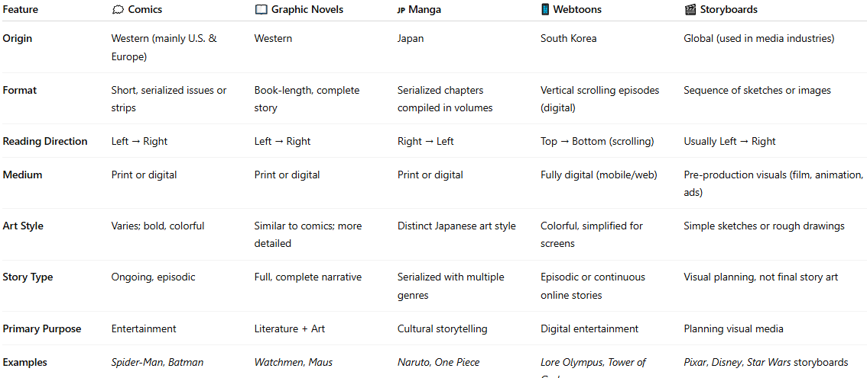
Feature | 🗯️ Comics | 📖 Graphic Novels | 🇯🇵 Manga | 📱 Webtoons | 🎬 Storyboards
Origin | Western (mainly U.S. & Europe) | Western | Japan | South Korea | Global (used in media industries)
Format | Short, serialized issues or strips | Book-length, complete story | Serialized chapters compiled in volumes | Vertical scrolling episodes (digital) | Sequence of sketches or images
Reading Direction | Left → Right | Left → Right | Right → Left | Top → Bottom (scrolling) | Usually Left → Right
Medium | Print or digital | Print or digital | Print or digital | Fully digital (mobile/web) | Pre-production visuals (film, animation, ads)
Art Style | Varies; bold, colorful | Similar to comics; more detailed | Distinct Japanese art style | Colorful, simplified for screens | Simple sketches or rough drawings
Story Type | Ongoing, episodic | Full, complete narrative | Serialized with multiple genres | Episodic or continuous online stories | Visual planning, not final story art
Primary Purpose | Entertainment | Literature + Art | Cultural storytelling | Digital entertainment | Planning visual media
Examples | Spider-Man, Batman | Watchmen, Maus | Naruto, One Piece | Lore Olympus, Tower of God | Pixar, Disney, Star Wars storyboards

🖼️ In short:
# Source: AI Source: Provided by: [Data Path: Persons Table -> ID Column: 1, Name_En Column: Motasem Essam] -> From: [ChatGPT] on [10/28/2025]
Sequential Art = Art + Storytelling through a sequence of images
It’s the umbrella term that includes comics, graphic novels, and manga — the visual equivalent of how movies use scenes or how books use chapters to tell a story.

